From: http://www.bloomberg.com/news/articles/2016-04-29/unmasking-the-men-behind-zero-hedge-wall-street-s-renegade-blog

Renegade Blog
The veil is lifted on a secretive website
Colin Lokey, also known as "Tyler Durden," is breaking the first rule of Fight Club: You do not talk about Fight Club. He’s also breaking the second rule of Fight Club. (See the first rule.) [It appears that it would be at most appropriate to have called Colin Lokey “one of the Tylers”. –FNC]

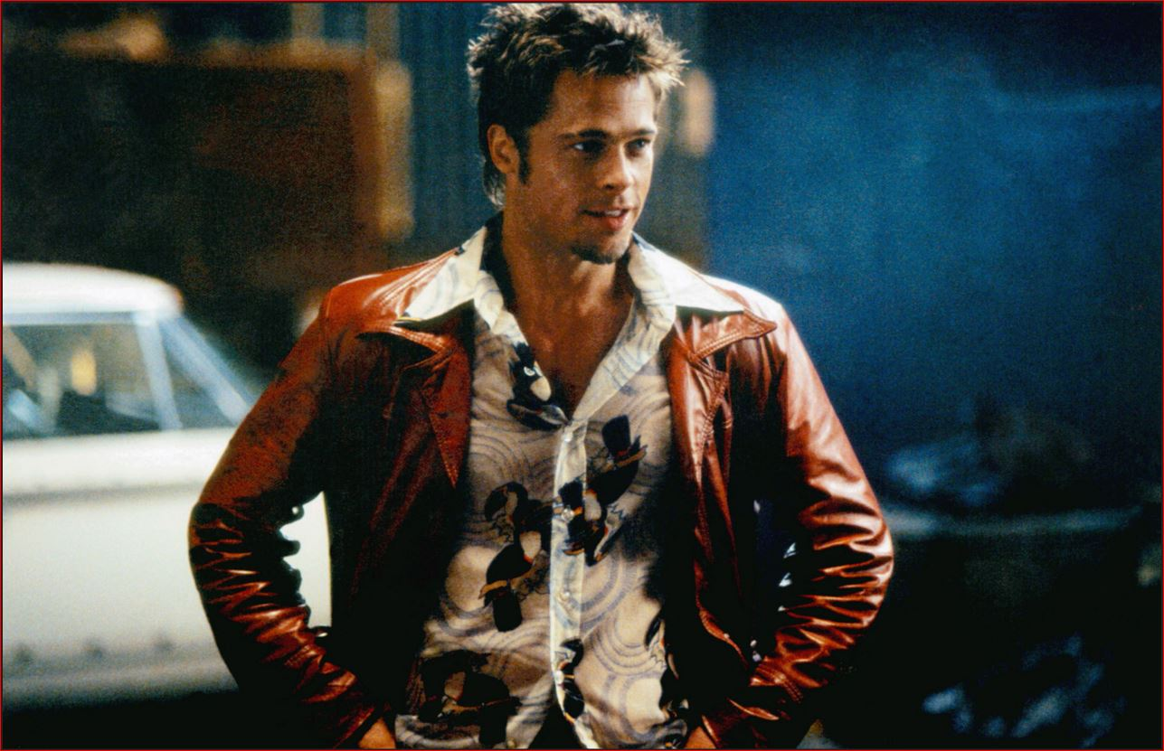
Tyler Durden in Fight Club (played by Brad Pitt)
After more than a year writing for the financial website Zero Hedge under the nom de doom of the cult classic’s anarchic hero, Lokey’s going public. In doing so, he’s answering a question that has bedeviled Wall Street since the site sprang up seven years ago: Just who is Tyler Durden, anyway?
The answer [ for the last year or so], it turns out , is three people. Following an acrimonious departure this month, in which two-thirds of the trio traded allegations of hypocrisy and mental instability, Lokey, 32, decided to unmask himself and his fellow Durdens.
Lokey said the other two men are Daniel Ivandjiiski, 37, the Bulgarian-born former analyst long reputed to be behind the site, and Tim Backshall, 45, a well-known credit derivatives strategist. (Bloomberg LP competes with Zero Hedge in providing financial news and information.)
In a telephone interview, Ivandjiiski confirmed that the men had been the only Tyler Durdens on the payroll since Lokey came aboard last year, but he criticized his former colleague's decision to come forward.
He called Lokey's parting gift a case of sour grapes. Backshall, meanwhile, declined to comment, referring questions to Ivandjiiski. A political science graduate with an MBA and a Southern twang, Lokey said he had a checkered past before joining Zero Hedge. Earlier this month, overwork landed him in a hospital because he felt a panic attack coming on, he said.
“Ultimately we wish Colin all the best, he’s clearly a troubled individual in many ways, and we are frankly disappointed that he’s decided to take his displeasure with the company in such a public manner,” Ivandjiiski said.

The Schism
Ivandjiiski worked for a hedge fund before being barred by the Financial Industry Regulatory Authority in 2008 for insider trading. He didn’t admit or deny wrongdoing, the agency said. Backshall is a familiar face on financial news networks who has been quoted by media outlets, including Bloomberg. His involvement with Zero Hedge, along with that of Lokey, hasn’t been widely known.
The schism between the men sheds light on a website popular among market professionals, one that mixes detailed financial analysis with sensational headlines such as "The Coming War Will Solve Our Unemployment & Growth Problem" and "Exposed—How Two Janet Yellen Phone Calls Saved The World."
Since being founded in the depths of the financial crisis, Zero Hedge has grown from a blog to an Internet powerhouse. Often distrustful of the “establishment” and almost always bearish, it's known for a pessimistic world view. Posts entitled “Stocks Are In a Far More Precarious State Than Was Ever Truly Believed Possible” and “America's Entitled (And Doomed) Upper Middle Class” are not uncommon.
The site’s ethos is perhaps best summed up by the tagline at the top of its homepage, also borrowed from Fight Club: “On a long enough timeline the survival rate for everyone drops to zero.” A paean to populism, the 1999 film is filled with loathing for consumerism and the financial system. Brad Pitt portrays Tyler Durden as hell-bent on bringing down the corrupt system of the global elite—an attitude often reflected in Zero Hedge’s content.
With that in mind, the website has argued that “pseudonymous speech” is necessary amid an atmosphere of stifled public dissent—hence the "Tyler Durden" alias was born. In earlier years, Durden was joined by "Marla Singer," another Fight Club character, as one of the site’s most prominent authors.
“It reminds me of a successful information operation where you mix in the propaganda stories along with other legitimate stories,” said Craig Pirrong, finance professor at the University of Houston. “There are some interesting things on it, and then there are the crazy things.”

Profit Motive
Despite holding itself out as a town crier for market angst, transcripts from Zero Hedge internal chat sessions provided by Lokey reveal a focus on Web traffic by the Durdens. Headlines are debated and a relentless publishing schedule maintained to keep readers sated. Lokey said the emphasis on profit—and what he considered political bias at the site—motivated him to quit.
He pointed to the wealth of the Durdens as a factor. Ivandjiiski has a multimillion-dollar mansion in Mahwah, N.J., and Backshall lives in a plush San Francisco suburb—not exactly reflections of Pitt's anticapitalist icon. “What you are reading at Zero Hedge is nonsense. And you shouldn’t support it,” Lokey wrote in an e-mail. “Two guys who live a lifestyle you only dream of are pretending to speak for you.”
Lokey adds: “Durden lives in a castle. If you’ve seen Fight Club, you know how ironic that is.”
A former “director of contributor success” at website Seeking Alpha, Lokey said he joined Zero Hedge for $6,000 a month and received an annual bonus of $50,000, earning more than $100,000 last year. His salary helped pay the rent on a “very nice” condominium on South Carolina’s Hilton Head Island, he said. Despite the compensation, he contends that he left because he disagreed with the site's editorial vision. “Reality checks are great. But Zero Hedge ceased to serve that public service years ago,” Lokey wrote. “They care what generates page views. Clicks. Money.”
Zero Hedge founder Ivandjiiski defended the site, adding that it's designed to be a for-profit entity. “Ultimately, the website makes money, and it’s profitable, which is also why we’ve never had to seek outside funding or any outside money—our only revenue is from advertising, always has been since day one,” he said. “Obviously, every publisher’s mission is to maximize revenue and page views, and we think that we do it in a way that is appropriate.”

Outside the Bubble
Any website's focus on traffic and revenue certainly isn't unusual. But Lokey said he was irked by what he saw as the hypocrisy of Zero Hedge and how it runs counter to its antiestablishment image. In the chat transcripts, Ivandjiiski refers to America's “silent majority” as “beastly,” while Backshall acknowledges life in the U.S. is bad “outside of my bubble.”
Ivandjiiski disagreed with the suggestion that personal worth or lifestyle precluded them from donning the mask of Durden (the character who quipped “the things you own end up owning you”) to deride the prevailing order. “We’ve never said that we are pro-socialist,” he said.
Lokey, who said he wrote much of the site’s political content, claimed there was pressure to frame issues in a way he felt was disingenuous. “I tried to inject as much truth as I could into my posts, but there’s no room for it.
- “Russia=good.
- Obama=idiot.
- Bashar al-Assad=benevolent leader.
- John Kerry= dunce.
- Vladimir Putin=greatest leader in the history of statecraft,”
Lokey wrote, describing his take on the website's politics. Ivandjiiski countered that Lokey could write “anything and everything he wanted directly without anyone writing over it.”
Working at Zero Hedge was also exhausting, Lokey said, and typically involved early morning starts and writing as many as 15 posts a day of as many as 1,500 words each. The work didn’t stop on the weekends, either. Text messages exchanged between Lokey and Ivandjiiski, screen shots of which were provided by the latter, paint the picture of a work environment that ranged from exhilarating to exasperating.
For instance, Lokey says he's “scared to even ask for an hour off,” while Ivandjiiski replies that “if you ever need time off for whatever reason, never hesitate to just ask.” In February, Lokey says, “I love this company and this website,” and tells Ivandjiiski “you saved my life,” expressing thanks for the job.
By April 2, 2016—the day Lokey left Zero Hedge—their relationship had deteriorated significantly, according to the messages provided by Ivandjiiski.
“I can’t be a 24-hour cheerleader for
- Hezbollah,
- Moscow,
- Tehran,
- Beijing, and
- Trump
anymore. It’ s wrong. Period. I know it gets you views now, but it will kill your brand over the long run,” Lokey texted Ivandjiiski. “This isn’t a revolution. It’s a joke.”

From: http://www.zerohedge.com/news/2016-04-29/full-story-behind-bloombergs-attempt-unmask-zero-hedge

The Full Story Behind Bloomberg's Attempt To "Unmask" Zero Hedge

Submitted by Tyler Durden on 04/29/2016 07:41 -0400

Over the years, Zero Hedge has proven to be a magnet for media attention.
It started years ago with a NY Magazine article published in September 2009 which first "unmasked" the people behind Zero Hedge with the "The Dow Zero Insurgency: The nothing-can-be-believed chaos of the financial crisis created a golden opportunity for a blog run by a mysterious ex-hedge-funder with a dodgy past and conspiracy theories to burn" in which we were presented as a bunch of "conspiracy theory" tin foil hat paranoid loons.
We are ok with being typecast as "conspiracy theorists" as these "theories" tend to become "conspiracy fact" months to years later.
Others, such as "academics who defend Wall Street to reap rewards" had taken on a different approach, accusing the website of being a "Russian information operation", supporting pro-Russian interests, which allegedly involved KGB and even Putin ties, simply because we refused to follow the pro-US script. We are certainly ok with being the object of other's conspiracy theories, in this case completely false ones since we have never been in contact with anyone in Russia, or the US, or any government for that matter. We have also never accepted a dollar of outside funding from either public or private organization - we have prided ourselves in our financial independence because we have been profitable since inception.
Which brings us to the latest "outing" of Zero Hedge, this time from none other than Bloomberg which this morning leads with "Unmasking the Men Behind Zero Hedge, Wall Street's Renegade Blog" in which it makes the tacit admission that "Bloomberg LP competes with Zero Hedge in providing financial news and information."
To an extent we were surprised, because while much of the "information" Bloomberg claims it reveals could have been discovered by anyone with a cursory 30 second google search, this time the accusation lobbed at Zero Hedge by Bloomberg was a new one:that we are capitalists who seek to generate profits and who have expectations from our employees.
This comes from a media organization which caters to Wall Street and is run by one of the wealthiest people in the world.
Underlying the entire Bloomberg article is disclosure based on a former employee at Zero Hedge.
Traditionally we don't reply to such media stories but in this case we'll make an exception as there is a substantial amount of information Bloomberg has purposefully failed to add.
* * *
Zero Hedge hired Colin when he approached us over a year ago begging for a job after he was fired with cause from Seeking Alpha following a fight with a coworker. This should have set off alarm flags but we ignored it.
Colin was a good writer, covering topics ranging from finance to economic to politics. Oddly enough, Colin had no qualms with capitalism when he accepted the money he was paid: as Bloomberg wrote, "his salary helped pay the rent on a “very nice” condominium on South Carolina’s Hilton Head Island." Perhaps he should have refused any compensation to demonstrate his allegiance to some "anticapitalist" cause?
More importantly, and unfortunately, Colin also was revealed to be an emotionally unstable, psychologically troubled alcoholic with a drug dealer past, as per his own disclosures.
All of these revelations were made clear to us long after we hired Colin, and unfortunately they were the catalyst that precipitated his full emotional collapse and ultimately led to his abrupt departure. All of these fact were also made clear to Bloomberg as part of its source "fact-checking."
Colin's departure, triggered by what readers will see was a near psychological breakdown, is also the basis for the Bloomberg article: as Colin made it clear to us, in his latest emotional outburst, he meant to "destroy" the website and has used Bloomberg as a platform in his attempt to discredit it.
Which is ironic because as recently as two months ago Colin was thanking us for "saving his life" and that ZH is the most important thing in his life. The last thing he wanted to do was "fuck it up" as he admitted in a text message.
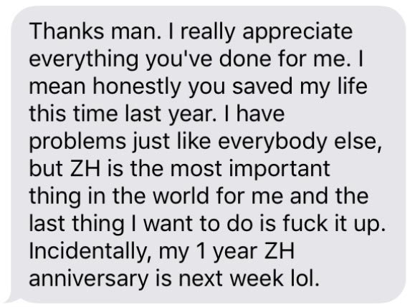

* * *
Alas, as often happens, the reality is different from what is being presented in the mainstream media, as readers will shortly find out.
But first, we would like to address a key false claim that Bloomberg makes, namely the following:
Lokey, who said he wrote much of the site’s political content, claimed there was pressure to frame issues in a way he felt was disingenuous. “I tried to inject as much truth as I could into my posts, but there’s no room for it. “Russia=good. Obama=idiot. Bashar al-Assad=benevolent leader. John Kerry= dunce. Vladimir Putin=greatest leader in the history of statecraft,” Lokey wrote, describing his take on the website's politics. Ivandjiiski countered that Lokey could write “anything and everything he wanted directly without anyone writing over it.”
He adds: “I can’t be a 24-hour cheerleader for Hezbollah, Moscow, Tehran, Beijing, and Trump anymore. It’ s wrong. Period."
He is absolutely correct: nobody ever asked Colin to be that, and Zero Hedge is most certainly not that - what it is, is the other side of the story which usually is not reported and the one that will make readers think.
To be sure, not only was Colin never told how or what to write when covering any given topic, he was never editorialized. Any topic, subject and story he wanted to write about was his entirely own, and he was never pressured with an "angle" which is much more than we can say for most of our competitors. What is amusing is that at first Lokey accused Zero Hedge of having a pro-Trump agenda, which then mysteriously morphed just days later into the old "pro-Putin" fallback. However, as he admits, he was never actually told how or what to write, he merely "thought" this was the case.
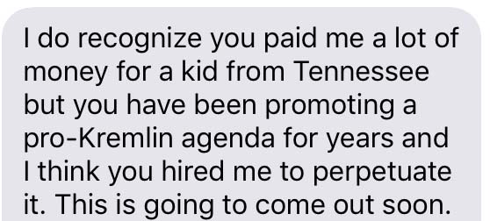

Another false allegation was that "Lokey says he's “scared to even ask for an hour off,” while Ivandjiiski replies that “if you ever need time off for whatever reason, never hesitate to just ask.” In February, Lokey says, “I love this company and this website,” and tells Ivandjiiski “you saved my life,” expressing thanks for the job."
Indeed he did, as recently a two months ago, or just a month before his departure. And more to the point, we repeatedly asked Colin if he needs "time off". Yet somehow Bloomberg is reporting as if he was afraid to "even ask for an hour off."
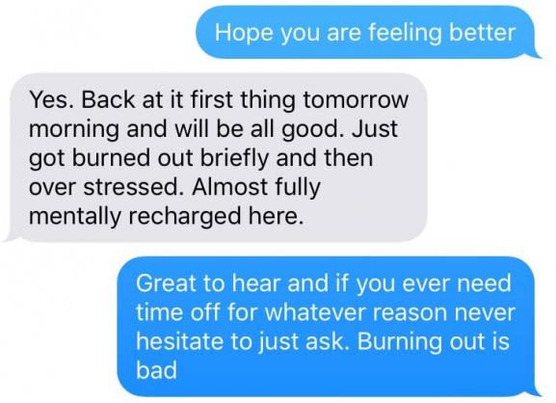

Unfortunately, this is the pattern of lies that emerged in recent months and culminated with today's Bloomberg hitpiece.
* * *
Below we will provide factual examples that corroborate that what Bloomberg's article is nothing more than a disgruntled employee seeking media attention in his attempt to "destroy" his former employer.
First, some insight into Colin's repeated alcohol abuse, the underlying reason for his what until recently were inexplicable to us mood swings, and sadly, the steady deterioration of his work product.
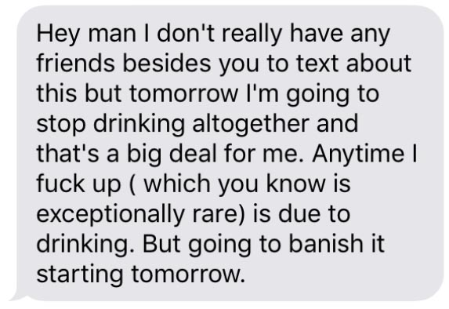
He said that in February. He failed to "banish it" as his drinking not only got worse, it nearly led to Colin committing himself. The drinking continued.
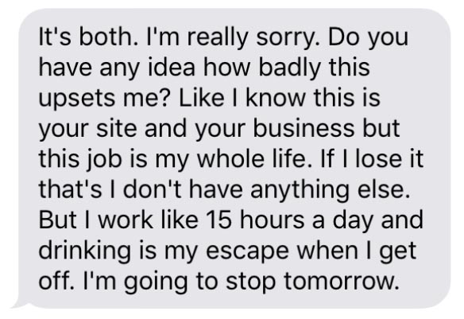

Conveniently Bloomberg ignored to add that its source was an alcoholic. It also ignored to add that its source had and still has deep psychological problems. In fact, as he himself admitted his problem is like "some physical sickness." It got so bad, he first resigned two months ago as a result of his most recent emotional collapse.

... Only to beg for his job back just hours later.
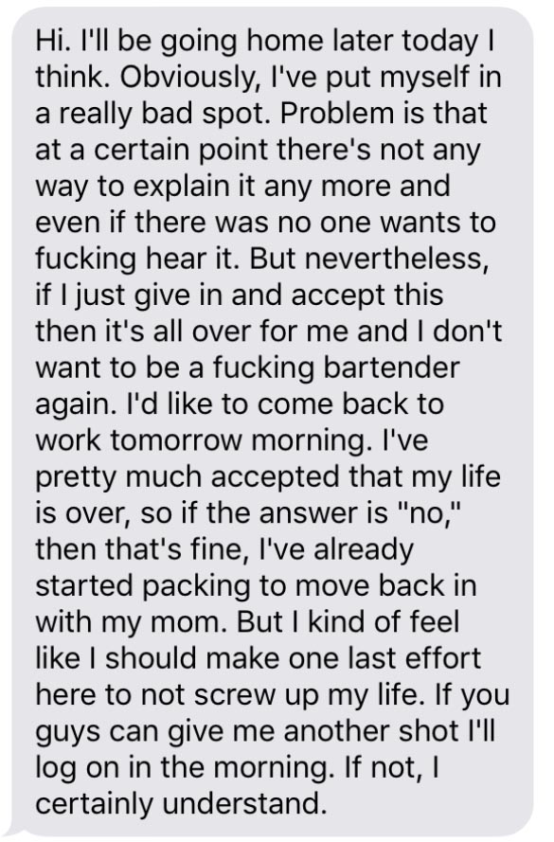

We decided to give him another chance: after all he was certainly a good writer which is why, incidentally, nobody ever edited, pressured or adjusted his writing contrary to his allegations.
Alas, it continued, and Colin had another major relapse promptly thereafter.
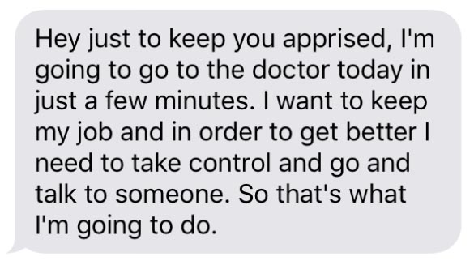
We wanted to help Colin, but not even he had any idea how to help himself. Sadly, his drinking would continue, as would his trips to get hospitalized in order to get help.
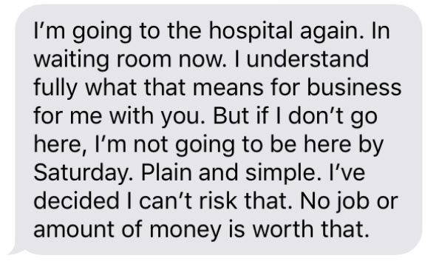

Colin admitted that his emotional trouble were so bad he had to be given a therapist and given Ativan.
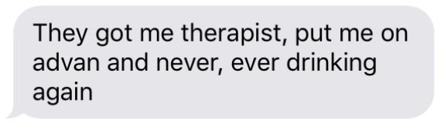
Once again, he begged for forgiveness, and once again we granted it.
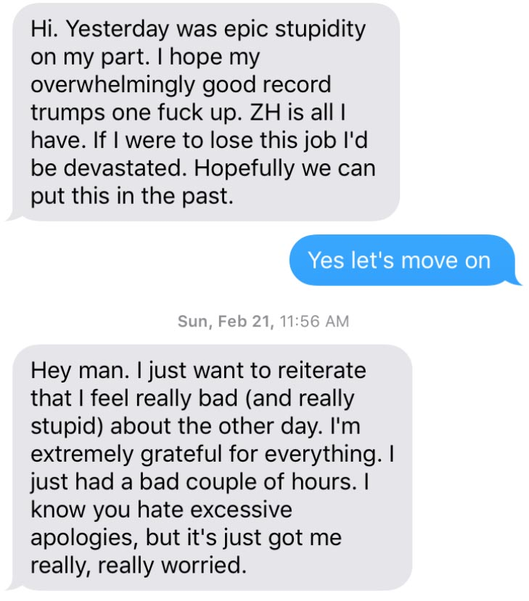
This was followed by more hospital trips, and more excuses about his steadily deteriorating work product.


Ultimately what was going on with Colin's mental state was something that he himself dubbed "incomprehensible and frightening."
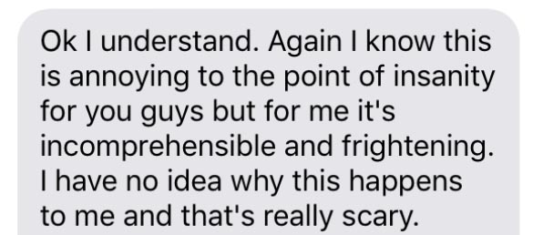

And then it was finally revealed the reason for his recurring mental problems: they were a remnant from his drug dealing days, a fact he presented to us for the first time just weeks ago.
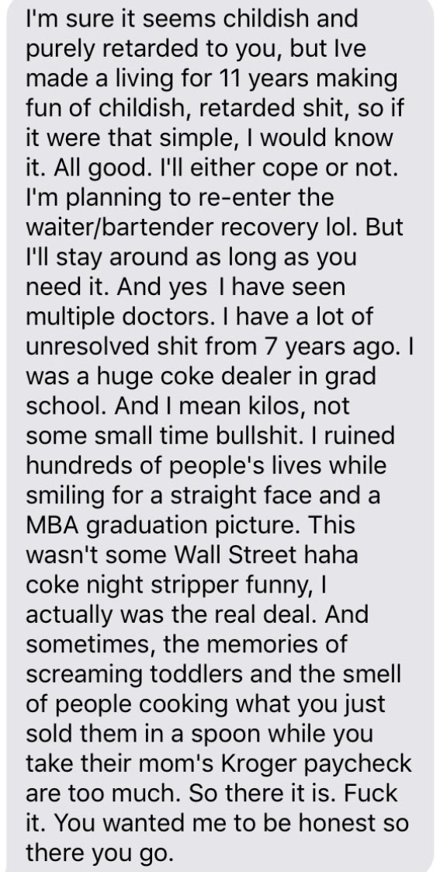

All of this went on for weeks and months, and culminated with yet another promise that Colin will "fix this."
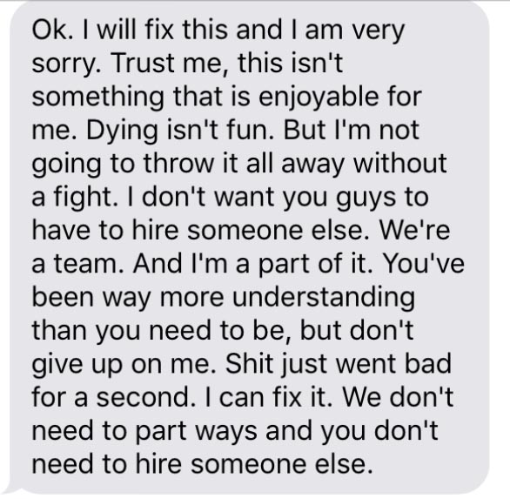

A few days later Colin had his final mental breakdown, which culminated with his explicit desire to "shut it down", for which he would use a very willing "competitor" Bloomberg...
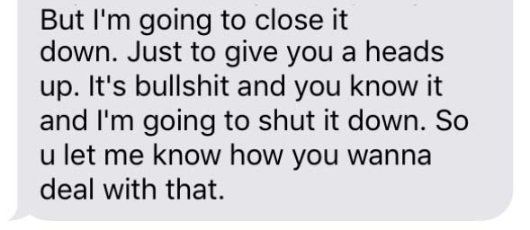
... Coupled with a death threat.
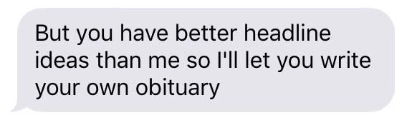

This is the objective source that "competitor" Bloomberg used for their piece.
* * *
Regarding, the actual content of Bloomberg's platform giving voice to a disturbed individual, former drug dealer and alcoholic, we find it particularly amusing as it "accuse" Zero Hedge of being intent on generating profits.
Coming from Bloomberg we find this not only entertaining but somewhat hypocritical.
Yes, Zero Hedge does and needs to generate a profit as nobody else would provide the funding needed to us, especially since our message is a simple one: the one the mainstream media will usually refuse to touch or discuss. We find it particularly amusing that Bloomberg quotes quotes Lokey as saying "he was irked by what he saw as the hypocrisy of Zero Hedge and how it runs counter to its antiestablishment image."
This may have been the underlying problem confusing Colin because it is not an "antiestablishment image" - it is a website whose mission is clearly stated in our manifesto:
our mission:
- to widen the scope of financial, economic and political information available to the professional investing public.
- to skeptically examine and, where necessary, attack the flaccid institution that financial journalism has become.
- to liberate oppressed knowledge.
- to provide analysis uninhibited by political constraint.
- to facilitate information's unending quest for freedom
our method: pseudonymous speech...

anonymity is a shield from the tyranny of the majority. it thus exemplifies the purpose behind the bill of rights, and of the first amendment in particular: to protect unpopular individuals from retaliation-- and their ideas from suppression-- at the hand of an intolerant society.

...responsibly used.

the right to remain anonymous may be abused when it shields fraudulent conduct. but political speech by its nature will sometimes have unpalatable consequences, and, in general, our society accords greater weight to the value of free speech than to the dangers of its misuse.
- mcintyre v. ohio elections commission 514 u.s. 334 (1995) justice stevens writing for the majority

though often maligned (typically by those frustrated by an inability to engage in ad hominem attacks) anonymous speech has a long and storied history in the united states. used by the likes of mark twain (aka samuel langhorne clemens) to criticize common ignorance, and perhaps most famously by alexander hamilton, james madison and john jay (aka publius) to write the federalist papers, we think ourselves in good company in using one or another nom de plume. particularly in light of an emerging trend against vocalizing public dissent in the united states, we believe in the critical importance of anonymity and its role in dissident speech. like the economist magazine, we also believe that keeping authorship anonymous moves the focus of discussion to the content of speech and away from the speaker- as it should be. we believe not only that you should be comfortable with anonymous speech in such an environment, but that you should be suspicious of any speech that isn't.
* * *
As for what we actually do, we find it surprising that someone needs an explanation: after all all our content hits the website as soon as it is published and is immediately vetted by all our readers. Indeed, as we have said from day one, the content should speak for itself, disintermediated from the messenger, which ultimately is the whole point. We believe that our readers agree with us.
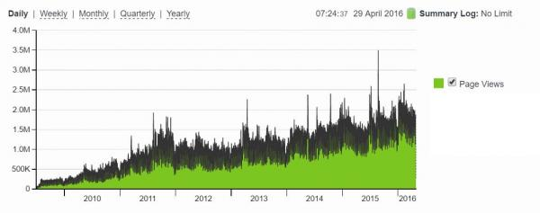
Incidentally, the chart above may explain why none other than our "competitor" Bloomberg decided it was its mission to voice a grievance of a disgruntled former employee who admitted it was his intention to "destroy" Zero Hedge.

